**User Interface and Practice 2015**

**Homework 2**

**Title :** **Rock-paper-scissors**

**Due Date:** **Week 14** (during practical class)

**Description :**

**Rock-paper-scissors** is a commonly played zero sum hand game which involve TWO players X and Y. Each player will simultaneously form one of three shapes with an outstretched hand. The shapes are “rock”, “paper”, and “scissors”. The game of the rules:

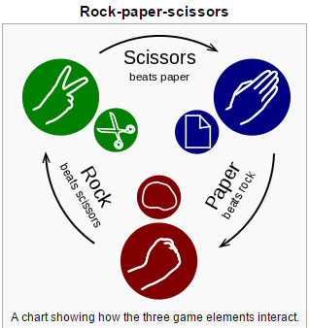

1. Rock will beat scissors
2. Paper will beat rock
3. Scissors will beat paper
4. Same of leads to tied game and replayed to break the tie

(Source from : https://en.wikipedia.org/wiki/Rock-paper-scissors)

**Requirements :**

In this homework, you are required to create an Android app that can play the Rock-paper-scissors game. You should fulfill the following requirements:

1. Create an application using Android.
2. Create a AI player as your opponent. This AI player should decide the shape randomly.
3. You should use the image to represent the shape.
4. You can refer to the sample screen design provided or design your own interface.

Rock-Paper-Scissors

Human Player

AI Player









Preference Setting

Save to file

1. When one of the players won, you should create a dialog to announce the winner.
2. You should have a button to let the user set information in for preference. In the preference setting, you should enable to let user to choose the number of game. For example 3 game, 5 game. And the name of user.
3. You should also have a button to allow the user to save the result to file. The name of player and the result of game should be included in the file when button “Save” clicked.